Skin Composer
in
LibGDX

Skin composer
What Is Skin Composer?
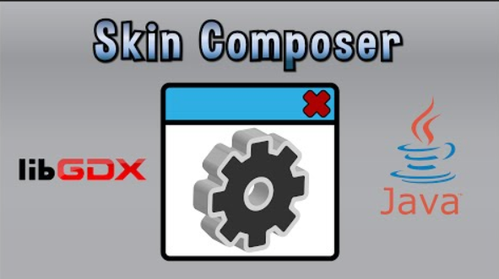
- Skin Composer is a program created for the need to create our own skins.

Skin composer
What Skin Composer Does?
- Provides a simple user interface to visually create skins for LibGDX scene2d.ui.

- Import assets and values from existing skins.

- Compatible with Windows, Linux, and Mac.d

- Exports a skin json file with a matching texture atlas.

- Allows for easy selection and organization of bitmap fonts, images, and colors.

Skin composer
- Download

Https://github.com/raeleus/skin-composer/releases/

